Jeff Levine
CS499 – Mod 3 – Journal

“How might you use an ePortfolio for the benefit of self-promotion?”
I think the best use of the portfolio is to showcase my technical knowledge and highlight marketable skills. It also allows me to highlight current trends in libraries, structure, and acumen by giving organized visuals.
“How might you mitigate risks while maximizing the marketing potential of the ePortfolio?”
Depending upon what I want to be available, there is always the privacy settings. Additionally, I can utilize the gitignore file so that certain assets are hidden.
“Describe possible downsides or risks—for instance, the risks of posting intellectual property online for public consumption.”

“Which course outcomes have you achieved so far, and which ones remain?”
I have completed the initial Software Design and Engineering enhancements, primarily to the UI forms and layouts. The components for the proposed enhancements for the other sections have been created and populated with some mock ups of how I envision their implementation.

Updates
## Software Engineering & Design
- Reactive Forms // Done
- Edit Trip // Done
- New Trip // Done
- Login // Done
- Responsiveness for selected trips and menus // Done
- Logs layout
- Create Logs listing component // Done
- Create Log component
- Create Log data service
- Mockup Log listing // Done
- User Management layout
- Create User listing component // Done
- Create User component
- Create Users data service
- Mockup user management listing // Done
- Routes for logs and users // Done
- Loading notifications
- Delete trip reimplementation
- Redirect to login if not logged in
- Component commenting updates // Done

## Algorithms & Data Structures
- Pagination mockup // Done
- Pagination layout // Done
- Data filters

## Database & Security
- Data propagation
- Access control enhancements
- Create Logs schema
- User Management schema

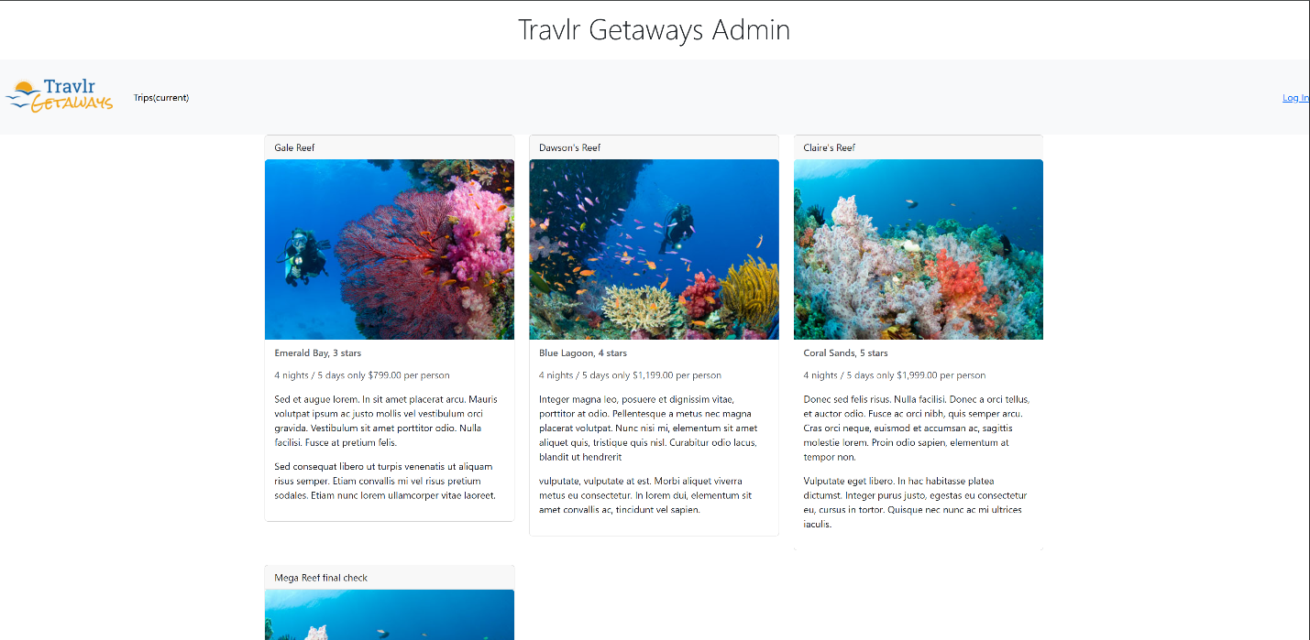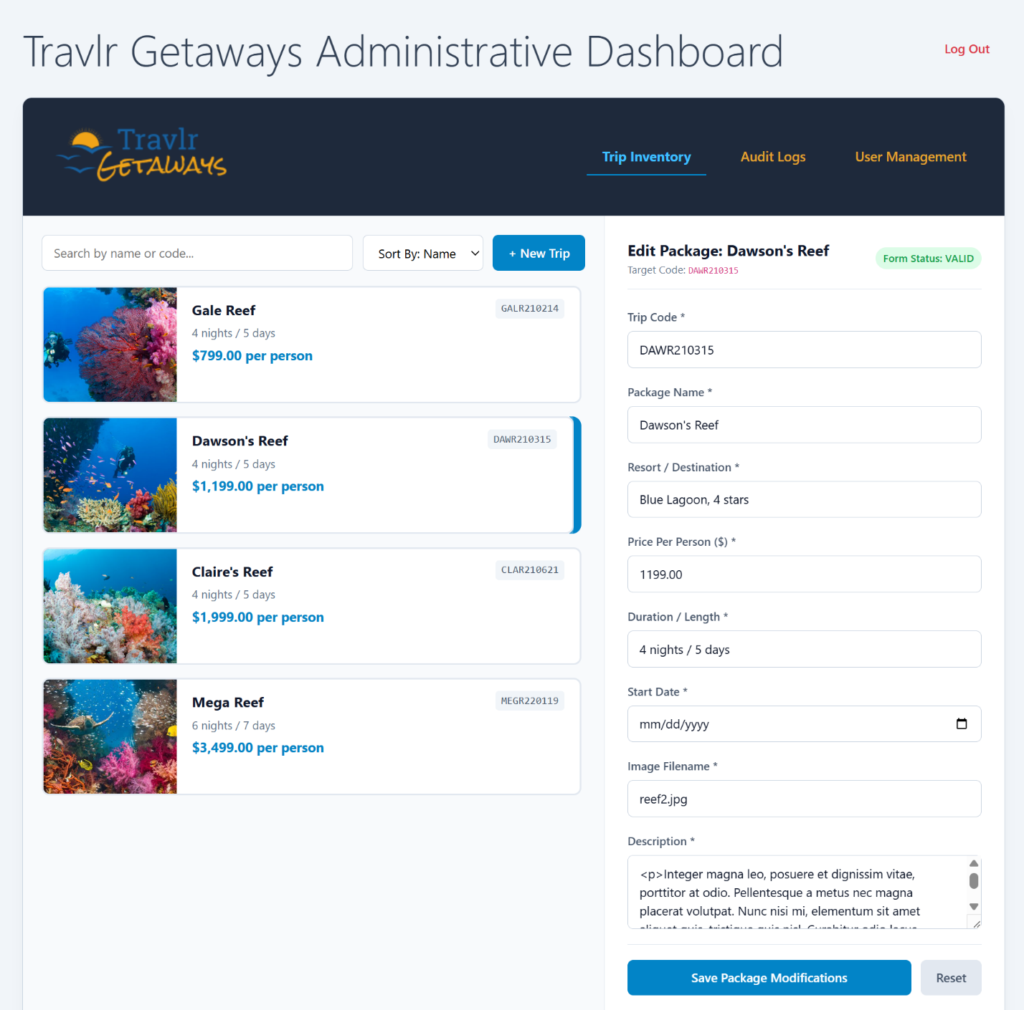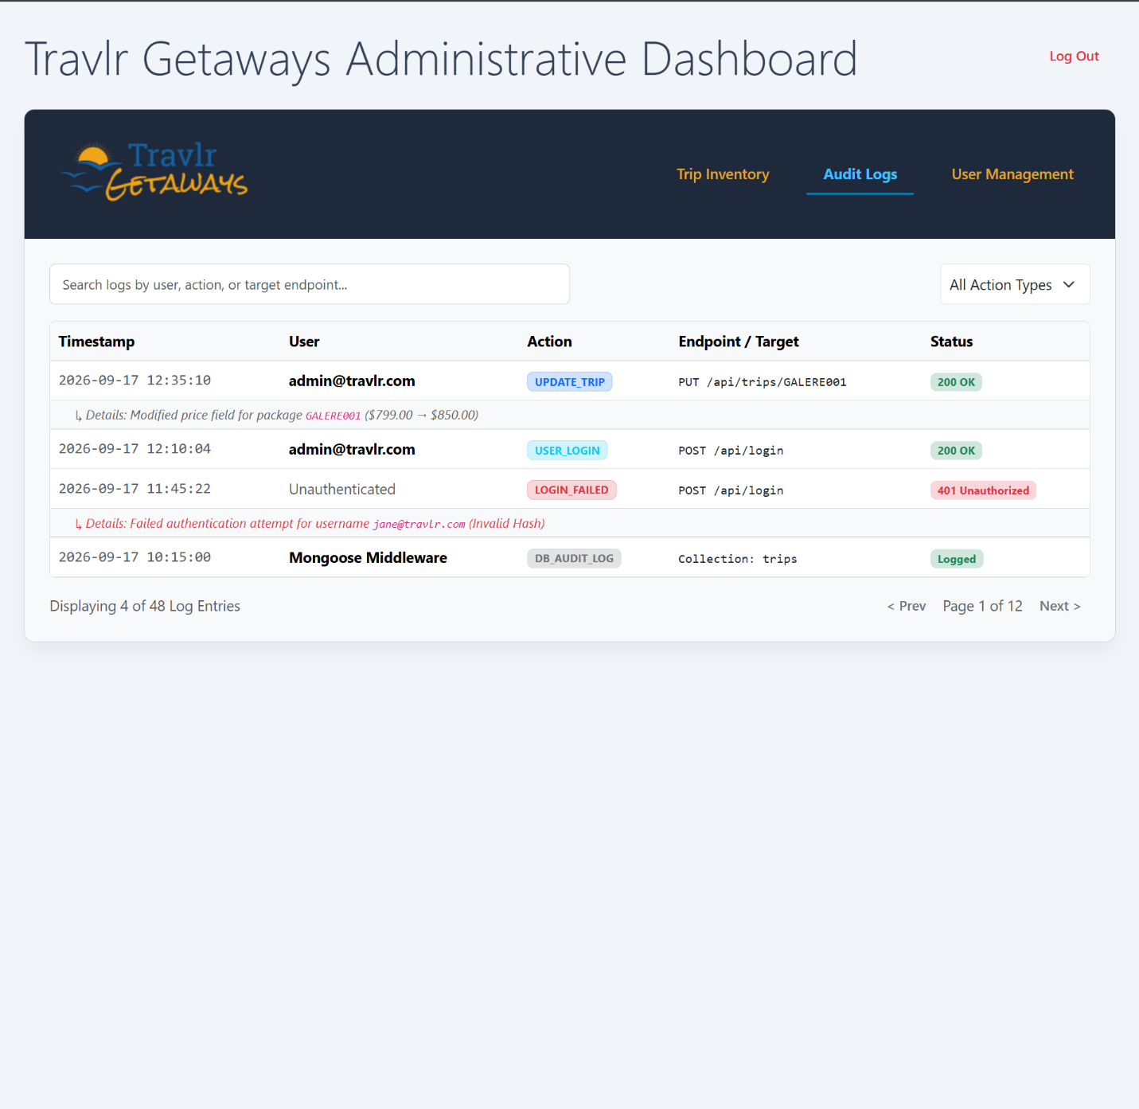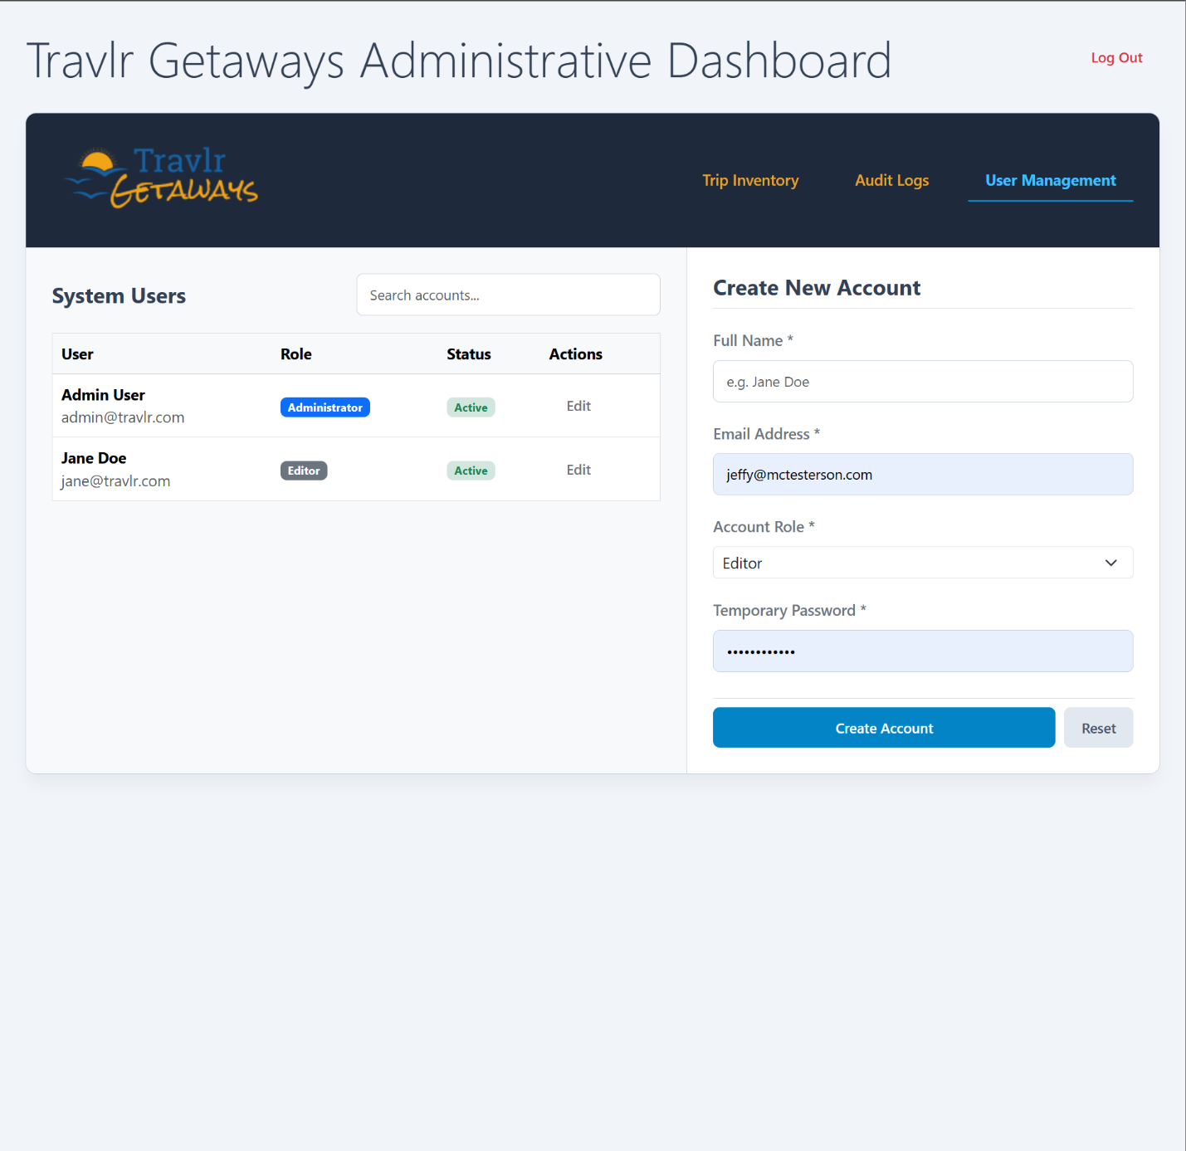
Status Checkpoints for All Categories
Checkpoint | Software Design and Engineering | Algorithms and Data Structures | Databases
Name of Artifact Used | Travlr Getaways | Travlr Getaways | Travlr Getaways
Status of Initial Enhancement | Complete
Submission Status | Submitted
Status of Final Enhancement | Ongoing
Uploaded to ePortfolio | Created new repo
Status of Finalized ePortfolio | Ongoing

https://github.com/jlevine84/cs499-eportfolio

